URL: https://adityabirlahospital.com/blogs/seasonal-allergies-in-children/

Meta Title: Seasonal Allergies in Children: Causes & Care | ABMH

Meta Description: Get clear information on childhood seasonal allergies, including symptoms, causes, and care tips to support your child through allergy season.

Seasonal Allergies in Children: Causes, Symptoms & Care

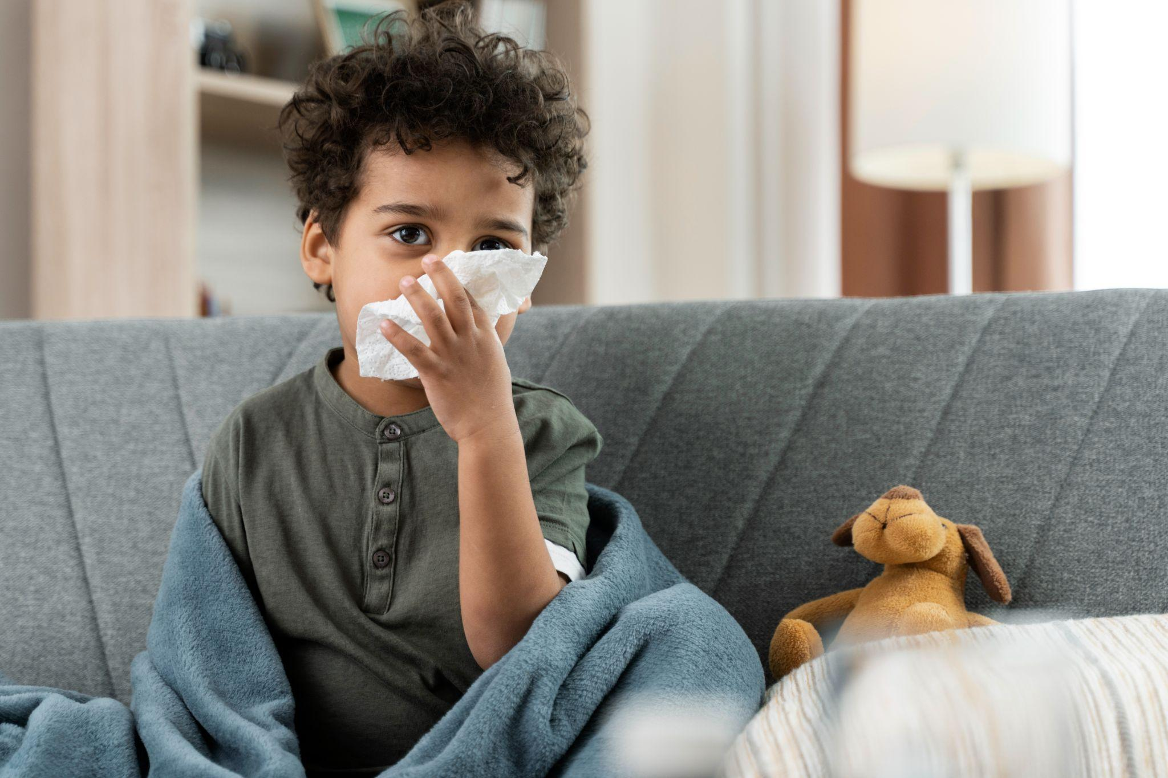

Changing seasons bring excitement—longer days, blooming flowers, and more time outdoors. But for many children, spring or autumn also means sneezing fits, itchy eyes, and constant sniffles. These are signs of seasonal allergies, a common issue among kids that can affect their daily life, sleep, and overall happiness.
This guide helps you understand what causes allergies in children, what symptoms to look for, and how to care for your child during allergy season.
What Are Seasonal Allergies?
Seasonal allergies in children happen when their immune system overreacts to substances in the air—usually pollen from trees, grasses, and weeds. These particles are harmless for most people, but in allergic children, they trigger uncomfortable symptoms.
Unlike food allergies or year-round allergies (like to dust mites or pets), seasonal allergies appear during specific times of the year—often spring, summer, or early fall—when certain plants release pollen.
Children usually don’t develop seasonal allergies until they’re at least two years old, as their bodies need time and repeated exposure to allergens to build up a reaction.
Common Causes of Allergies in Children
Let’s take a closer look at what causes these allergic reactions in kids:
1. Pollen: The most common trigger, pollen comes from trees (spring), grasses (late spring and early summer), and weeds (late summer and fall).
2. Mold Spores: Mold grows in damp areas like piles of leaves, compost, or bathrooms.
3. Weather and Environment: Hot, dry, and windy days often have higher pollen counts.
4. Family History: Genetics play a strong role in allergy development.
Symptoms of Seasonal Allergies in Children
Symptoms may look like a cold at first, but they tend to linger and follow a pattern each year. Common signs include:
- Runny or stuffy nose
- Sneezing
- Itchy, watery eyes
- Dry cough
- Fatigue
- Dark circles under the eyes
- Postnasal drip
- Abdominal pain in children (from mucus)
How Are Allergies Diagnosed?
Diagnosis may involve:
- A physical exam and health history
- Skin prick tests
- Blood tests to measure allergic reactions
Pediatric Allergy Treatment Options
Treating seasonal allergies in children involves:
1. Avoidance Techniques: Keep windows closed, use air purifiers, shower after outdoor play.
2. Medication: Antihistamines, nasal sprays, and eye drops can help.
3. Immunotherapy: Allergy shots to build tolerance over time.
Tips for Managing Seasonal Allergies at Home
Here are a few parent-friendly steps to reduce allergy flare-ups:
- Track pollen counts
- Keep indoor air clean
- Change clothes after outdoor play
- Hydrate well
- Use warm compresses
When to See a Doctor
Consult a doctor if:
- Symptoms persist
- Medications stop working
- Wheezing or trouble breathing
- Frequent abdominal pain
- Allergies interfere with daily activities
Choosing the Right Care: Best Pediatric Hospital in Pune
The Best Pediatric Hospital in Pune will have:
- Pediatric allergists
- Modern diagnostic tools
- Personalized care plans
- A supportive healthcare team
Final Thoughts
Seasonal allergies in children are common but manageable. Understand the causes of allergies in children, spot symptoms early, and take action. With proper support from the best pediatrician in Pune or the best pediatric hospital in Pune, your child can thrive in every season.

